Arbitrage Fund Analyser – v0 Spec
Oct 7, 2026 · @Nikhil

Goal and scope
v0 is an internal tool that compares arbitrage funds on returns, costs and size, against the benchmark.
- Users: internal only. Runs on one laptop.
- Funds: 8 arbitrage funds, direct growth plans. Kotak, SBI, ICICI Pru, Invesco, ABSL, Tata, Nippon, Edelweiss.
- History: from 01-Jan-2019.
- Later: other fund categories, external users, a chatbot. The design must not block these.

Data sources
All fund data comes from AMFI and is automated. Only the benchmark and two config fields are manual. The AMFI code links every dataset.
Data | Source | Frequency | How
Daily NAV | mfapi.in (republishes AMFI data) | Daily | Automated
TER breakdown (base, brokerage, transaction, levies, total) | AMFI TER page | Monthly | Manual upload
Average AUM, scheme-wise | AMFI Average AUM page | Quarterly | Manual upload (Excel export)
Launch date | First date in NAV history | One-time | Automated
Benchmark: Nifty 50 Arbitrage Index | niftyindices.com | Monthly upload | Manual
Exit load, fund manager | Config file | On change | Manual
Fund list, category and AMFI codes | Config file | One-time | Manual
- AMFI AAUM is in Rs lakhs. Store in Rs crore.
- Use the same benchmark index version as the factsheets, every time.
- Resolved during build: AMFI's NAV history allows only 90 days per download, so NAV comes from mfapi.in, with code, ISIN and plan checked each refresh. No AMFI API for TER and AAUM could be verified, so both are file uploads.

Data validation
Every load runs these checks. A failed check is flagged on screen, not silently dropped. No separate NAV-vs-price check is needed: for a mutual fund, NAV is the price.
Data | Check | Rule
NAV | Missing dates | Gap longer than 5 calendar days → flag
NAV | Duplicate dates | Same date twice → flag
NAV | Bad values | Zero or negative → flag
NAV | Unusual daily move | Outside the fund's normal range (method below) → flag
Benchmark upload | Bad values | Zero, negative, duplicate or weekend dates → reject file
Benchmark upload | Date gaps | Gap longer than 5 calendar days → flag
Benchmark upload | Outliers | Same normal-range method as NAV, on the index → flag
Benchmark upload | Overlap match | Dates already stored must match within 0.01 → else reject file
Fund mapping | Plan type | Scheme name contains "Direct" and "Growth"
AUM, TER | Units | AMFI AAUM in Rs lakhs → store in Rs crore
Spot check | Manual | Monthly: latest NAV of 1 to 2 funds vs AMC website
Normal range method (NAV and benchmark)
- Daily change = today's value / previous value − 1.
- Divide by calendar days between the two dates. Arbitrage NAV accrues over weekends, so a Monday move is naturally larger.
- Normal range = the series' median absolute daily change over the last 250 trading days.
- Flag if today's change is more than 10× that median.
- Tune the 10× once on 2019–2026 data, so only a handful of days per fund per year are flagged.
A flag means review, not delete. Small negative days are normal for arbitrage funds; only large ones flag.
Overlap match: each benchmark file usually repeats dates already stored. Those values must equal the stored ones. A mismatch means a wrong file or a different index version (for example price instead of total return). The file is rejected, and nothing is overwritten.

Calculations
All returns use direct-plan NAV, so costs are already deducted. Returns over 1 year are annualised (CAGR).
Metric | Definition
Point-to-point return | NAV(end) / NAV(start), annualised, for 1Y, 3Y, 5Y
Rolling return | Return over each 1Y, 3Y, 5Y window, one window per trading day
Rolling stats | Average, median, min, max, % of windows above a chosen level
Tracking difference | Fund return minus benchmark return, same window
Rolling tracking difference | Tracking difference for every rolling window
TER | Base and total TER, latest and trend
AUM | Latest quarterly AAUM, in Rs crore
- Missing date (holiday): use the nearest earlier value.
- A window needs a full history. Data starts 01-Jan-2019, so the chart's first 1Y point is Jan 2020, 3Y is Jan 2022, 5Y is Jan 2024.

Screens and requirements
v0 has three screens. Every table can be sorted and exported to CSV.
Common filter
- Fund category: single-select, on Fund comparison and Rolling returns. v0 has one value: Arbitrage. New categories appear here as they are added.
- The funds list and all tables show only funds in the selected category.
1. Fund comparison
- One row per fund: AUM, base TER, total TER, exit load, manager, launch date.
- Returns: 1Y, 3Y, 5Y point-to-point, with tracking difference vs benchmark.
- Flags: exit load above 0.25%, data check failures.
2. Rolling returns
- Funds: multi-select, pick 1 or more (up to 8). Window: 1Y, 3Y or 5Y.
- Time-series chart: rolling return per day for each selected fund, from 01-Jan-2019 data.
- Benchmark line on the same chart, styled differently.
- Stats table under the chart: average, median, min, max, % of windows above a chosen level, average tracking difference.
- Hover shows date, fund, value.
3. Data health
- Last refresh date per dataset.
- Validation results and any flags.
- Benchmark CSV upload button.
Daily refresh
- One script pulls new NAV each day; TER monthly; AUM quarterly.
- Missed days are caught up on the next run.

Mock
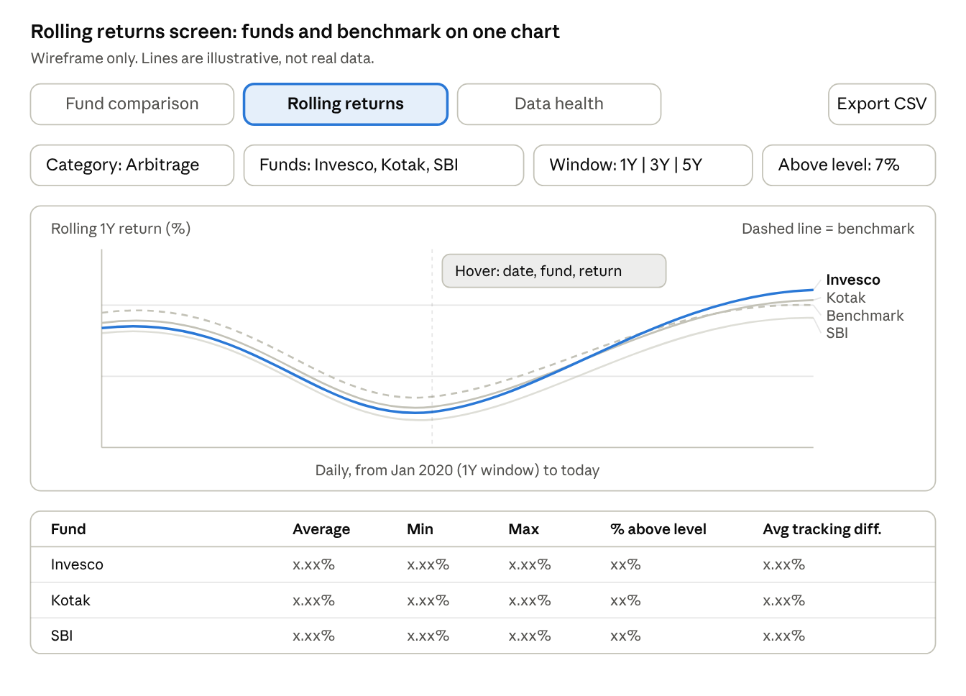
wireframe · Rolling returns screen · illustrative lines, not real data
The chart shows each fund's rolling return day by day, with the benchmark dashed. The stats table under it summarises the same windows. The Fund comparison screen is a plain sortable table with the columns listed above.
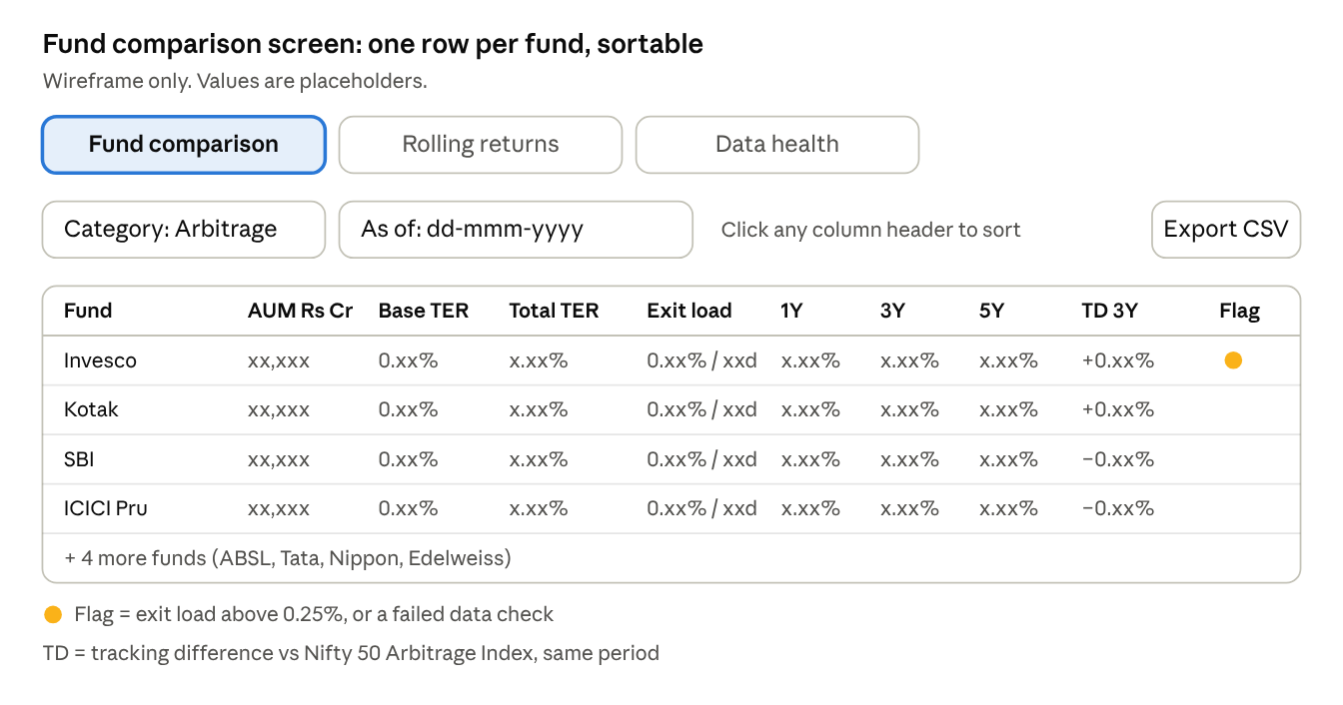
wireframe · Fund comparison screen · placeholder values
The Fund comparison screen is the landing page: one sortable row per fund, with a flag for anything that needs a look.
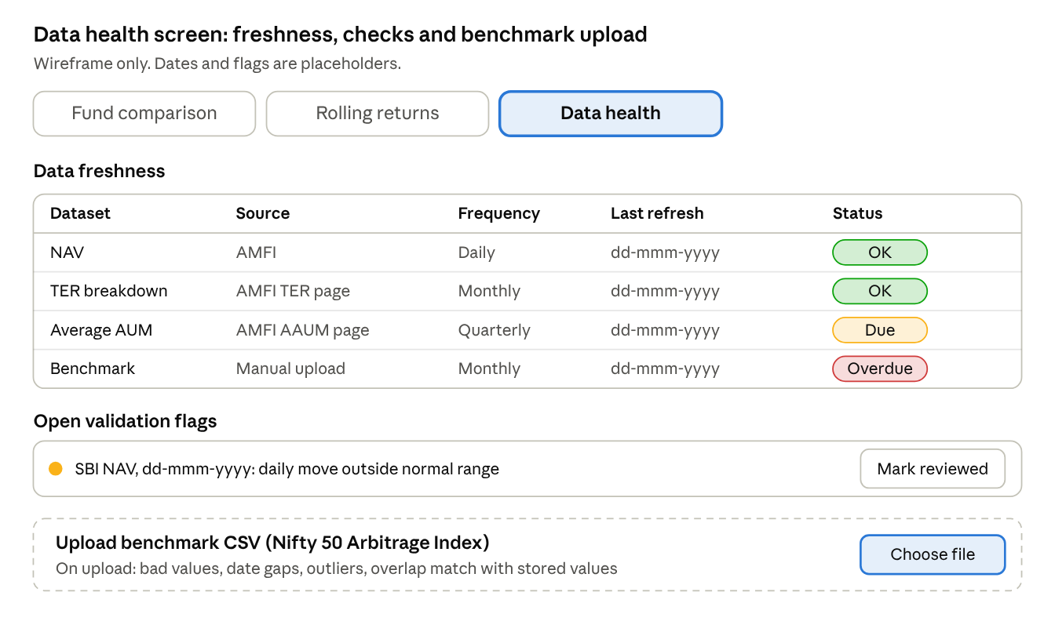
wireframe · Data health screen · placeholder dates and flags
The Data health screen shows how fresh each dataset is, lists open flags to review, and takes the monthly benchmark upload.

Tech stack and storage
Python, pandas and Streamlit, with one SQLite file on the laptop.
- Calculations: a separate Python module, not inside UI code. A future API or chatbot reuses it as is.
- Storage: SQLite file. 8 funds, 5+ years is about 1 to 2 MB. No server, no setup.
- Tables: funds, nav, benchmark, ter, aum, validation_log.
- Backup: copy the .db file to Google Drive weekly.
- Later: FastAPI over the module when a second consumer appears. Postgres and a cloud server when others need access.

Out of scope for v0
- Monthly portfolio holdings (hedge %, debt quality). Planned for v2, with AI extraction.
- Monthly month-end AUM from factsheets. TER breakdown and quarterly Average AUM are built but switched off for now (config [settings.features]).
- Other fund categories.
- External users, login, chatbot.
- Scores or buy recommendations.

